Most Useful Civil Engineering Software In 2023
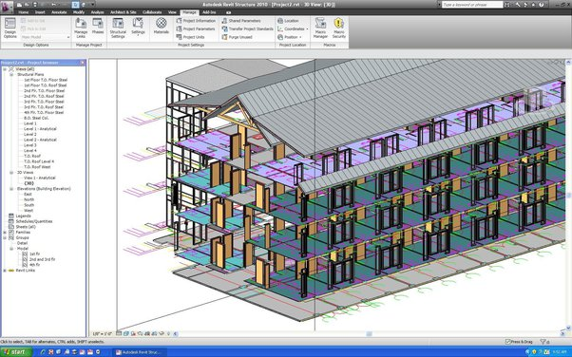

Introduction
🏗️ Civil engineering is a vast field that involves various complex calculations and designs. With the advancement of technology, several software tools have emerged that can aid in simplifying the design and construction process. In 2023, there are several civil engineering software tools that are trending and are expected to be useful in the upcoming years. In this blog, we will discuss some of the most useful civil engineering software tools in 2023, along with their features and applications.

1.Autodesk Civil 3D 🏗️
Autodesk Civil 3D is a powerful software tool for civil engineers that helps in designing and analysing infrastructure projects such as roads, highways, and land development. It has a range of features including land development, stormwater management, and geospatial analysis. It can be used to create detailed 3D models of infrastructure projects, which can be used to identify potential design flaws and improve project efficiency.

2.Bentley MicroStation 🏗️
Bentley MicroStation is another popular software tool for civil engineers that helps in creating 2D and 3D designs for infrastructure projects. It is widely used in the architecture, engineering, and construction industry, and it is known for its high level of customization and flexibility. It can be used for creating detailed drawings, performing calculations, and analysing infrastructure projects.

3.AutoCAD Civil 3D 🏗️
AutoCAD Civil 3D is a comprehensive software tool that is widely used by civil engineers for designing and analysing infrastructure projects. It has a range of features including land development, surveying, and transportation design. It can be used to create detailed 3D models of infrastructure projects, which can be used to identify potential design flaws and improve project efficiency.

4.STAAD Pro 🏗️
STAAD Pro is a structural analysis and design software tool that is used by civil engineers for designing and analyzing structures such as buildings, bridges, and tunnels. It is known for its high level of accuracy and can be used to perform complex calculations related to structural design. It has a range of features including finite element analysis, seismic analysis, and design optimization.

5.ETABS 🏗️
ETABS is a structural analysis and design software tool that is used by civil engineers for designing and analysing structures such as buildings, bridges, and tunnels. It is known for its high level of accuracy and can be used to perform complex calculations related to structural design. It has a range of features including finite element analysis, seismic analysis, and design optimization.

6.Revit 🏗️
Revit is a building information modelling software tool that is used by civil engineers for creating 3D models of buildings and structures. It is widely used in the architecture, engineering, and construction industry, and it is known for its high level of accuracy and efficiency. It has a range of features including visualisation, documentation, and collaboration.

7.Tekla Structures 🏗️
Tekla Structures is a structural design and analysis software tool that is used by civil engineers for designing and analyzing structures such as buildings, bridges, and tunnels. It is known for its high level of accuracy and can be used to perform complex calculations related to structural design. It has a range of features including 3D modeling, visualization, and documentation.

8.Autodesk Revit Live 🏗️
Autodesk Revit Live is a software tool that allows civil engineers to create interactive 3D models of buildings and structures. It can be used to create virtual tours of buildings and structures, which can be used for marketing and educational purposes. It has a range of features including visualisation, collaboration, and documentation.

9.Trimble SketchUp 🏗️
Trimble SketchUp is a 3D modelling software tool that is widely used by civil engineers for creating detailed models of buildings and structures. It has a range of features including 3D modelling, visualisation, and collaboration. It is known for its user-friendly interface and can be used for a wide range of applications including architecture, interior design, and urban planning.

10.CivilGEO 🏗️
CivilGEO is a comprehensive software tool that is used by civil engineers for designing and analysing infrastructure projects such as roads, highways, and land development. It has a range of features including hydrology, stormwater management, and geospatial analysis. It can be used to create detailed 3D models of infrastructure projects, which can be used to identify potential design flaws and improve project efficiency.
These are some of the most useful civil engineering software tools in 2023 that are widely used in the industry. However, it is worth mentioning that new software tools are constantly emerging, and it is important for civil engineers to stay up-to-date with the latest developments in the field.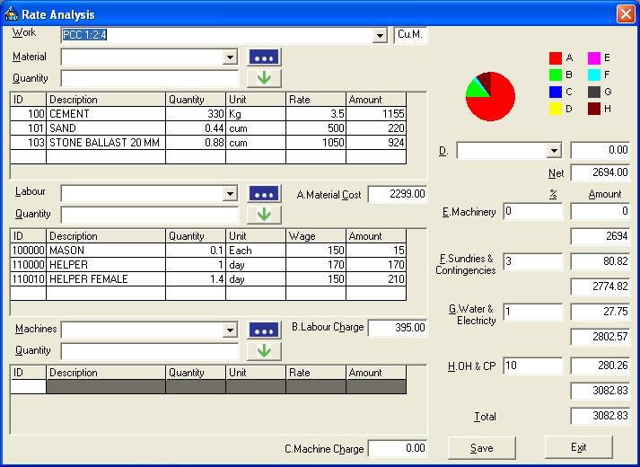

Some upcoming civil engineering software tools that are worth keeping an eye on in the future include:

- BIM 360 🏗️
BIM 360 is a cloud-based software tool that allows civil engineers to collaborate and manage infrastructure projects from anywhere in the world. It has a range of features including project management, collaboration, and documentation. It is expected to become increasingly popular in the upcoming years due to its ease of use and efficiency.

- Infraworks 🏗️
Infraworks is a software tool that is used for infrastructure design and planning. It allows civil engineers to create 3D models of infrastructure projects, which can be used to visualise the project and identify potential design flaws. It is expected to become increasingly popular in the upcoming years due to its ability to improve project efficiency and reduce costs.

Conclusion🎯
In conclusion, civil engineering software tools are essential for designing and analysing infrastructure projects. With the advancements in technology, new software tools are emerging, and existing software tools are being improved to provide more accurate and efficient solutions. The software tools mentioned in this blog are some of the most useful civil engineering software tools in 2023, and they are widely used in the industry. Civil engineers should stay up-to-date with the latest developments in the field to ensure that they are using the most efficient software tools for their projects.

